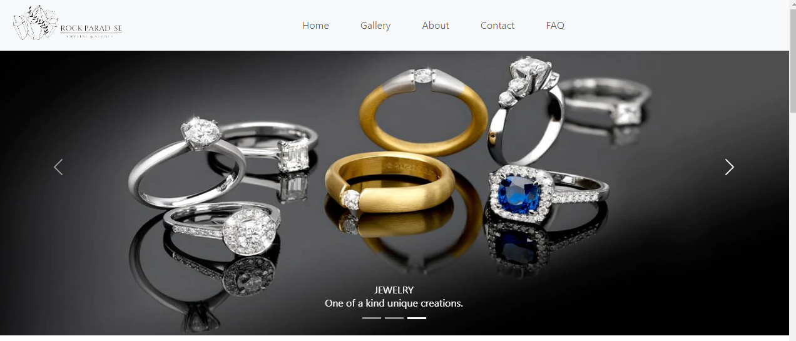

## Our Group Members:

## Muhammad Hammad Ali:

## (Student 1499468)

## Jazil Ahmed :

## (Student 1488951)

## Moiz:

## (Student 1488911)

## Curriculum Code:

**Submitted To:**

[eprojects@aptech.ac.in](mailto:eprojects@aptech.ac.in)

**Project Instructor:**

**SIR MUHAMMAD HASHIR**

## Muhammad Hammad Ali:

**Submitted To:**

[eprojects@aptech.ac.in](mailto:eprojects@aptech.ac.in)

**Project Instructor:**

**SIR MUHAMMAD HASHIR**

**Curriculum Code:**

**7062 AC**

## (OV-7066-HDSE)

## Jazil Ahmed :

## (OV-7062-HDSE)

## Moiz:

## (OV-7062-HDSE)

## 

## 

## TABLE OF CONTENT

**Project certification…………………………………………………….5**

**Introduction of Rock Paradise………………………………6**

**Requirement specification……………………………………………...7**

**Hardware/software requirements…………………………….……8**

**Home page…………………………………………………………………...13**

**About us……………………………………………………………………..…1**

**Contact us description………………………………….……………….15**



**ACKNOLEDGMENT**

**We are thankful to Almighty, ALLAH that by His grace we have been successful. We also thanks to “SIR MUHAMMAD HASHIR”**

**we presenting on Visual Studio Code in your hands.**

**This is our First Year Semester E-project. We have tried our best & struggled for a better outlook to come. This project has been developed in Visual Studio Code. We choose to make Webpage for Bakerz Bite as a project. We find easy to do coding in Visual Studio Code.**

**We earnestly hope that this project will provide all the necessarily information required for the user to fulfill their inspiration. However suggestions for improvement of the project will be thankful received & acknowledge**

**PROJECT CERTIFICATION**

***This is to certify that,***

***Jazil Ahmed (Enrolment # student 1488951), Muhammad Hammad Ali(Enrolment # student 1499468) & Moiz (Enrolment # student 1488911) has successfully designed and developed:***

**Rock Paradise**

***Submitted by***

***Aptech computer Education***

***Date of issue:***

**15-dec-2023**

***Date of submission:***

**05-jan-2024.**

**INTRODUCTION OF ROCK PARADISEHARDWARE&SOFTWARE/REQUIRMENT**

**We are a group of 3 student. We watch all sorts of Rock Paradise in all sorts of countries, then write reports and feature articles about them which are published in a newspaper. This is a fine and privileged occupation, and one to be disclosed with tact. People who do respectable, important jobs don’t like to hear about it.**

**1) The Home Page should be created making use of Frames.**

**2) A Menu should be created which would categorize all the information about the features provided in the Site For e.g. a Menu for Various Brands, a Menu for Features of Rock-Paradise etc etc something like that.**

**3) The Shop display should be categorized according to the Brand names of Rock-paradise like if a User wants to see only PENDORA Jewelery then he click on Some PENDORA Link/button etc and he will see only That Brand Rock-Paradise and so on.**

**4) A Products of features of Individual Rock-Paradise should be displayed on the Web Page along with the AC but detailed Features should be stored in Individual Word documents which can be downloaded or viewed by the User who wishes to see the same.**

**5) A Brands Web Page should also be there where there is Air-conditioner comparisons done with various models of same brand or various models of various brands.**

**- The Brands information should be provided in Tabular format comparing the features of different** Brands

**- This Brands would be for 5 Air-conditioner of similar brands and 2 C of different brands for 1 month and then it will change so for the time being the Page should handle the above requirement.**

**6) There should be a “Contact Us” page which will have the Address of the Company which is as follows and the mail address which when clicked will invoke the local mail client from where they can send an email**.

**Hardware:**

* **Intel Core i3/i5 Processor or higher.**
* **8 GB RAM or above.**
* **Color SVGA.**
* **500 GB Hard Disk space.**
* **Mouse.**
* **Keyboard.**

**Software:**

* **Frontend: HTML5, CSS, Bootstrap, JavaScript, jQuery, AngularJS, XML.**
* **Data Source: JSON files or TXT files.**

***Other Requirements*:**

*Operating Portal****:*** Windows.

*Browsers:*Edge, Chrome,

Mozilla Firefox, Safari.

**SYSTEM REQUIRMENT**

|  |  |  |
| --- | --- | --- |
| No. | Items | Description |
| 1 | **Operating System.** | **WINDOWS XP to 10(latest)** |
| 2 | **Main Processor.** | **Minimum 2.45 or better** |
| 3 | **RAM (Memory)** | **Minimum 256 or better** |
| 4 | **Web Browser** | **Google Chrome/Firefox** |
| 5 | **Software** | **Visual Studio Code** |

**HOME PAGE CODING**

<!DOCTYPE html>

<html lang="en">

<head>

    <meta charset="UTF-8">

    <meta name="viewport" content="width=device-width, initial-scale=1.0">

    <title>Rock Paradise</title>

    <link rel="stylesheet" href="https://cdnjs.cloudflare.com/ajax/libs/font-awesome/6.5.1/css/all.min.css" integrity="sha512-DTOQO9RWCH3ppGqcWaEA1BIZOC6xxalwEsw9c2QQeAIftl+Vegovlnee1c9QX4TctnWMn13TZye+giMm8e2LwA==" crossorigin="anonymous" referrerpolicy="no-referrer" />

    <link href="https://cdn.jsdelivr.net/npm/bootstrap@5.3.2/dist/css/bootstrap.min.css" rel="stylesheet" integrity="sha384-T3c6CoIi6uLrA9TneNEoa7RxnatzjcDSCmG1MXxSR1GAsXEV/Dwwykc2MPK8M2HN" crossorigin="anonymous">

<script src="https://cdn.jsdelivr.net/npm/bootstrap@5.3.2/dist/js/bootstrap.bundle.min.js" integrity="sha384-C6RzsynM9kWDrMNeT87bh95OGNyZPhcTNXj1NW7RuBCsyN/o0jlpcV8Qyq46cDfL" crossorigin="anonymous"></script>

<script src="jquery-3.7.1.min.js"></script>

<script src="https://cdn.tailwindcss.com"></script>

<link rel="stylesheet" href="./Libraries/owl carousel/OwlCarousel2-2.3.4/dist/assets/owl.carousel.min.css">

<script src="./Libraries/owl carousel/OwlCarousel2-2.3.4/dist/owl.carousel.min.js"></script>

<link rel="stylesheet" href="rockparadise.css">

</head>

<body>

  <!-- header -->

  <header>

    <nav class="navbar navbar-expand-lg navbar-light bg-light">

        <div class="container-fluid">

          <img class="logo" src="picture/logo_black.png" alt="">

          <button class="navbar-toggler" type="button" data-bs-toggle="collapse" data-bs-target="#navbarNav" aria-controls="navbarNav" aria-expanded="false" aria-label="Toggle navigation">

            <span class="navbar-toggler-icon"></span>

          </button>

          <div class=" navbar-collapse" id="navbarNav">

            <ul class="navbar-nav">

              <li class="nav-item">

                <a class="nav-link" href="#home">Home</a>

              </li>

              <li class="nav-item">

                <a class="nav-link" href="./gallery.html">Gallery</a>

              </li>

              <li class="nav-item">

                <a class="nav-link" href="#About">About</a>

              </li>

              <li class="nav-item">

                <a class="nav-link" href="#Contactus">Contact</a>

              </li>

              <li class="nav-item">

                <a class="nav-link" href="#FAQ">FAQ</a>

              </li>

            </ul>

          </div>

        </div>

      </nav>

</header>

    <!-- Home -->

    <section id="home">

    <!-- slider -->

    <div id="carouselExampleCaptions" class="carousel slide">

      <div class="carousel-indicators">

        <button type="button" data-bs-target="#carouselExampleCaptions" data-bs-slide-to="0" class="active" aria-current="true" aria-label="Slide 1"></button>

        <button type="button" data-bs-target="#carouselExampleCaptions" data-bs-slide-to="1" aria-label="Slide 2"></button>

        <button type="button" data-bs-target="#carouselExampleCaptions" data-bs-slide-to="2" aria-label="Slide 3"></button>

      </div>

      <div class="carousel-inner">

        <div class="carousel-item active">

          <img src="picture/slider1.jpg" class="d-block w-100" alt="...">

          <div class="carousel-caption d-none d-md-block">

            <h5>CRYSTAL</h5>

            <p>Looking for a crystal set to help you with your spiritual journey, home decor, or just as a gift</p>

          </div>

        </div>

        <div class="carousel-item">

          <img src="picture/slider2.jpeg" class="d-block w-100" alt="...">

          <div class="carousel-caption d-none d-md-block">

            <h5>GEMSTONE</h5>

            <p>Wide variety of agates by size and color.</p>

          </div>

        </div>

        <div class="carousel-item">

          <img src="picture/slider4.webp" class="d-block w-100" alt="...">

          <div class="carousel-caption d-none d-md-block">

            <h5>JEWELRY</h5>

            <p>One of a kind unique creations.</p>

          </div>

        </div>

      </div>

      <button class="carousel-control-prev" type="button" data-bs-target="#carouselExampleCaptions" data-bs-slide="prev">

        <span class="carousel-control-prev-icon" aria-hidden="true"></span>

        <span class="visually-hidden">Previous</span>

      </button>

      <button class="carousel-control-next" type="button" data-bs-target="#carouselExampleCaptions" data-bs-slide="next">

        <span class="carousel-control-next-icon" aria-hidden="true"></span>

        <span class="visually-hidden">Next</span>

      </button>

    </div>

          <!--- Special Items section-->

          <section id="menu-caro" class="container-fluid p-0 pb-5">

            <div id="menu-content" class="row container">

                <div style="font-family: Impact, Haettenschweiler, 'Arial Narrow Bold', sans-serif;" class="col-6 display-4 my-5 pt-5 text-center"> Special Items </div>

                <div class="col-6 display-4 my-5 pt-5 text-end">

                    <div class="slider-controls">

                        <button class="slider-prev"><i class="fas fa-arrow-left"></i></button>

                        <button class="slider-next"><i class="fas fa-arrow-right"></i></button>

                    </div>

                </div>

            </div>

            <div id="menu-slider" class="menu-slider owl-carousel container">

                <a href="./galleryjewelery/shopjewelery.html" target="_blank"><!-- Engagement Ring -->

                    <div class="menu-card container">

                        <img class="p-3" src="picture/schlumberger-by-tiffany-co-rope-engagement-ring-in-18k-gold-26291038_996096_ED_M.webp" alt="....">

                        <h1 class="p-3 ">Engagement Ring</h1>

                    </div>

                </a>

                <a href="./galleryjewelery/shopjewelery.html" target="_blank"><!-- Celestail Ring Set -->

                    <div class="menu-card container">

                    <img class="p-3" src="picture/NAMPS0438.jpg" alt="....">

                    <h1 class="p-3">Celestail Ring Set</h1>

                    </div>

                </a>

                <a href="./galleryjewelery/shopjewelery.html" target="_blank"><!-- Hyperbola Ring -->

                    <div class="menu-card container">

                        <img class="p-3" src="picture/hyperbola-cocktail-ring-special item.avif" alt="....">

                        <h1  class="p-3">Hyperbola Ring</h1>

                    </div>

                </a>

                <a href="./galleryjewelery/shopjewelery.html" target="_blank"><!-- Rock Vine Ring -->

                    <div class="menu-card container">

                        <img class="p-3" src="picture/tiffany-victoriavine-ring-68386594_1025726_ED_M.webp" alt="....">

                        <h1 class="p-3">Rock Vine Ring</h1>

                    </div>

                </a>

                <a href="./galleryjewelery/shopjewelery.html" target="_blank"><!-- Christmas Charm -->

                    <div class="menu-card container">

                        <img class="p-3" src="picture/special-item.jpg" alt="....">

                        <h1 class="p-3">Christmas Charm</h1>

                    </div>

                </a>

                <a href="./galleryjewelery/shopjewelery.html" target="_blank"><!-- Dextera Bangle -->

                    <div class="menu-card container">

                        <img class="p-3" src="picture/dextera-bangle--mixed-cuts-.avif" alt="....">

                        <h1 class="p-3">Dextera Bangle</h1>

                    </div>

                </a>

                <a href="./galleryjewelery/shopjewelery.html" target="_blank"><!-- Millenia Bracelet -->

                    <div class="menu-card container">

                        <img class="p-3" src="picture/millenia-bracelet--octagon-cut--blue--ruthenium-plated-swarovski-5671250.avif" alt="....">

                        <h1 class="p-3">Millenia Bracelet</h1>

                    </div>

                </a>

                <a href="./galleryjewelery/shopjewelery.html" target="_blank"><!-- Millenia earring -->

                    <div class="menu-card container">

                        <img class="p-3" src="picture/millenia-drop-earrings--octagon-cut--green--gold-tone-plated-swarovski-5676071.avif" alt="....">

                        <h1 class="p-3">Millenia earring</h1>

                    </div>

                </a>

            </div>

            <br>

            <br>

            <br>

            <br>

<!-- new collection -->

            <h1 style="font-family: Impact, Haettenschweiler, 'Arial Narrow Bold', sans-serif;" class="heading-new-collection">NEW COLLECTION</h1>

<div id="boxes">

    <div id="leftbox">

       <img class="collection-img" src="picture/NAMPS0420.jpg" alt="" srcset="">

    </div>

    <div id="middlebox">

        <img class="collection-img" src="picture/01bc263d-dfb8-440e-907a-8beff80ae1e7.webp" alt="" srcset="">

    </div>

    <div id="rightbox">

        <img class="collection-img" src="picture/81k1fn921lL._AC_SL1500_.jpg" alt="" srcset="">

    </div>

    <div id="leftbox1">

        <img class="collection-img" src="picture/c7cff292-9c4b-45d8-9608-1a274803cd98.webp" alt="" srcset="">

     </div>

     <div id="middlebox1">

         <img class="collection-img" src="picture/tiffany-victoriavine-ring-68386594_1025726_ED_M.webp" alt="" srcset="">

     </div>

     <div id="rightbox1">

         <img class="collection-img" src="picture/d9fbd5d5-a469-4245-97f1-a7ad1af6aa04.webp" alt="" srcset="">

     </div>

</div>

 </section>

**ABOUT US PAGE CODING**

<!-- About us -->

<section id="About">

<section class="py-3 py-md-5 py-xl-8">

  <div class="container">

    <div class="row">

      <div class="col-12 col-md-10 col-lg-8">

        <h3 class="fs-5 mb-2 text-secondary text-uppercase" id="aboutheadind">About</h3>

        <h2 class="display-5 mb-4" >Our journey began with a dream of redefining how the world perceives design.</h2>

      </div>

    </div>

  </div>

  <div class="container overflow-hidden">

    <div class="row gy-4 gy-lg-0">

      <div class="col-12 col-lg-6">

        <article>

          <div class="card border-0">

            <img class="card-img-top img-fluid m-0" loading="lazy" src="https://image.lexica.art/full_webp/820cde2b-ccc7-467c-bc14-5ee36e0d1def" alt="">

            <div class="card-body border bg-white p-4">

              <div class="entry-header mb-3">

                <h2 class="card-title entry-title h4 mb-0">

                  <a class="link-dark text-decoration-none" href="#!">Our Vision</a>

                </h2>

              </div>

              <p class="card-text entry-summary text-secondary mb-3">From sleek modernism to timeless elegance, we infuse every creation with a touch of our artistic ingenuity. As a design agency, great design can shape perceptions, inspire action, and leave an indelible mark on the world.</p>

            </div>

          </div>

        </article>

      </div>

      <div class="col-12 col-lg-6">

        <article>

          <div class="card border-0">

            <img class="card-img-top img-fluid m-0" loading="lazy" src="https://image.lexica.art/full_webp/4aeccbaa-4cf7-480f-8971-3d12c9f00198" alt="">

            <div class="card-body border bg-white p-4">

              <div class="entry-header mb-3">

                <h2 class="card-title entry-title h4 mb-0">

                  <a class="link-dark text-decoration-none" href="#!">Our Approach</a>

                </h2>

              </div>

              <p class="card-text entry-summary text-secondary mb-3">Welcome to our design agency, where creativity knows no bounds and innovation takes center stage. We are a team of dedicated designers, strategists, and visionaries with a passion for transforming ideas into captivating visuals.</p>

            </div>

          </div>

        </article>

      </div>

    </div>

  </div>

</section>

</section>

<!-- THE CEREBRAL STONE -->

<div class="clearfix">

  <img src="picture/pexels-arina-krasnikova-6998590.webp" class="col-md-6 float-md-end mb-3 ms-md-3" alt="...">

<br>

<br>

  <h1 class="the-stone">      THE CEREBRAL STONE

  </h1><br>

  <h2 class="Amethyst">

      AMETHYST

  </h2><br>

  <p class="stone-para">

      Amethyst boasts rich purple hues and cerebral properties which promote balance, tranquility, and spiritual insight. It is believed to defend against negative energies, transforming them into love and enhancing intuition. This gem is a symbol of inner strength and cherished in various cultures for jewelry and decorative home decor pieces.

  </p>

</div>

**CONTACT PAGE CODING**

<!-- Contact us -->

<section id="Contactus">

  <section class="text-gray-600 body-font relative">

      <div class="container px-5 py-24 mx-auto">

        <div class="flex flex-col text-center w-full mb-12">

          <h1 class="sm:text-3xl text-2xl font-medium title-font mb-4 text-gray-900">Contact Us</h1>

          <p class="lg:w-2/3 mx-auto leading-relaxed text-base">This site is protected by reCAPTCHA and the Google Privacy Policy and Terms of Service apply.</p>

        </div>

        <div class="lg:w-1/2 md:w-2/3 mx-auto">

          <div class="flex flex-wrap -m-2">

            <div class="p-2 w-1/2">

              <div class="relative">

                <label for="name" class="leading-7 text-sm text-gray-600">Name</label>

                <input required type="text" id="name" name="name" class="w-full bg-gray-100 bg-opacity-50 rounded border border-gray-300 focus:border-indigo-500 focus:bg-white focus:ring-2 focus:ring-indigo-200 text-base outline-none text-gray-700 py-1 px-3 leading-8 transition-colors duration-200 ease-in-out">

              </div>

            </div>

            <div class="p-2 w-1/2">

              <div class="relative">

                <label for=" Phone number" class="leading-7 text-sm text-gray-600">Phone Number</label>

                <input required type="Phone number" id="Phone number" name="Phone number" class="w-full bg-gray-100 bg-opacity-50 rounded border border-gray-300 focus:border-indigo-500 focus:bg-white focus:ring-2 focus:ring-indigo-200 text-

base outline-none text-gray-700 py-1 px-3 leading-8 transition-colors duration-200 ease-in-out">

              </div>

            </div>

            <div class="p-2 w-1/2">

              <div class="relative">

                <label for="email" class="leading-7 text-sm text-gray-600">Email</label>

                <input required type="email" id="email" name="email" class="w-full bg-gray-100 bg-opacity-50 rounded border border-gray-300 focus:border-indigo-500 focus:bg-white focus:ring-2 focus:ring-indigo-200 text-base outline-none text-gray-700 py-1 px-3 leading-8 transition-colors duration-200 ease-in-out">

              </div>

            </div>

            <div class="p-2 w-1/2">

              <div class="relative">

                <label for="Password" class="leading-7 text-sm text-gray-600">Password</label>

                <input required type="Password" id="Password" name="Password" class="w-full bg-gray-100 bg-opacity-50 rounded border border-gray-300 focus:border-indigo-500 focus:bg-white focus:ring-2 focus:ring-indigo-200 text-base outline-none text-gray-700 py-1 px-3 leading-8 transition-colors duration-200 ease-in-out">

              </div>

            </div>

            <div class="p-2 w-full">

              <div class="relative">

                <label for="message" class="leading-7 text-sm text-gray-600">Message</label>

                <textarea id="message" name="message" class="w-full bg-gray-100 bg-opacity-50 rounded border border-gray-300 focus:border-indigo-500 focus:bg-white focus:ring-2 focus:ring-indigo-200 h-32 text-base outline-none text-gray-700 py-1 px-3 resize-none leading-6 transition-colors duration-200 ease-in-out"></textarea>

              </div>

            </div>

            <div class="p-2 w-full">

              <button class="flex mx-auto text-white bg-blue-500 border-0 py-2 px-8 focus:outline-none hover:bg-blue-600 rounded text-lg">SEND</button>

            </div>

            <div class="p-2 w-full pt-8 mt-8 border-t border-gray-200 text-center">

              <a class="text-indigo-500">RockParadise@gmail.com</a>

              <p class="leading-normal my-5">49 Smith St.

                <br>Saint Cloud, MN 56301

              </p>

              <span class="inline-flex">

                <a class="text-gray-500">

                  <svg fill="currentColor" stroke-linecap="round" stroke-linejoin="round" stroke-width="2" class="w-5 h-5" viewBox="0 0 24 24">

                    <path d="M18 2h-3a5 5 0 00-5 5v3H7v4h3v8h4v-8h3l1-4h-4V7a1 1 0 011-1h3z"></path>

                  </svg>

                </a>

                <a class="ml-4 text-gray-500">

                  <svg fill="currentColor" stroke-linecap="round" stroke-linejoin="round" stroke-width="2" class="w-5 h-5" viewBox="0 0 24 24">

                    <path d="M23 3a10.9 10.9 0 01-3.14 1.53 4.48 4.48 0 00-7.86 3v1A10.66 10.66 0 013 4s-4 9 5 13a11.64 11.64 0 01-7 2c9 5 20 0 20-11.5a4.5 4.5 0 00-.08-.83A7.72 7.72 0 0023 3z"></path>

                  </svg>

                </a>

                <a class="ml-4 text-gray-500">

                  <svg fill="none" stroke="currentColor" stroke-linecap="round" stroke-linejoin="round" stroke-width="2" class="w-5 h-5" viewBox="0 0 24 24">

                    <rect width="20" height="20" x="2" y="2" rx="5" ry="5"></rect>

                    <path d="M16 11.37A4 4 0 1112.63 8 4 4 0 0116 11.37zm1.5-4.87h.01"></path>

                  </svg>

                </a>

                <a class="ml-4 text-gray-500">

                  <svg fill="currentColor" stroke-linecap="round" stroke-linejoin="round" stroke-width="2" class="w-5 h-5" viewBox="0 0 24 24">

                    <path d="M21 11.5a8.38 8.38 0 01-.9 3.8 8.5 8.5 0 01-7.6 4.7 8.38 8.38 0 01-3.8-.9L3 21l1.9-5.7a8.38 8.38 0 01-.9-3.8 8.5 8.5 0 014.7-7.6 8.38 8.38 0 013.8-.9h.5a8.48 8.48 0 018 8v.5z"></path>

                  </svg>

                </a>

              </span>

            </div>

          </div>

        </div>

      </div>

    </section>

  </section>

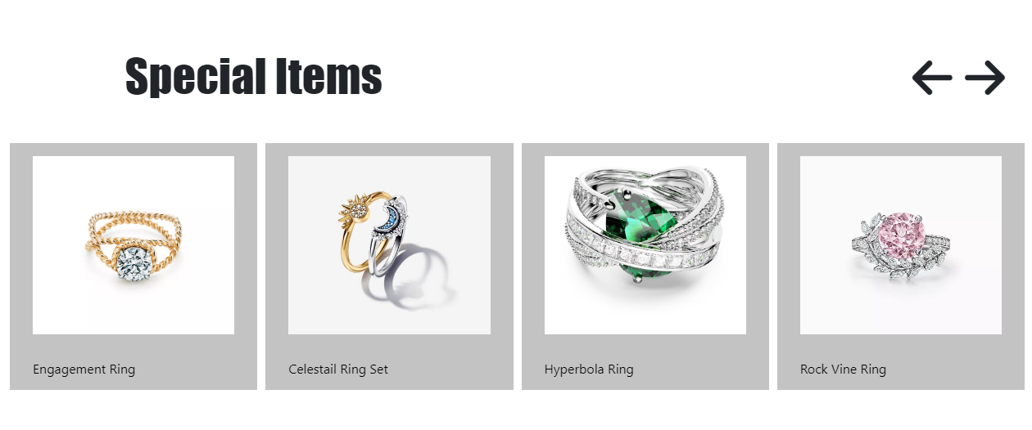**SPECIAL ITEM SECTION**

**CONTACT US PAGE**

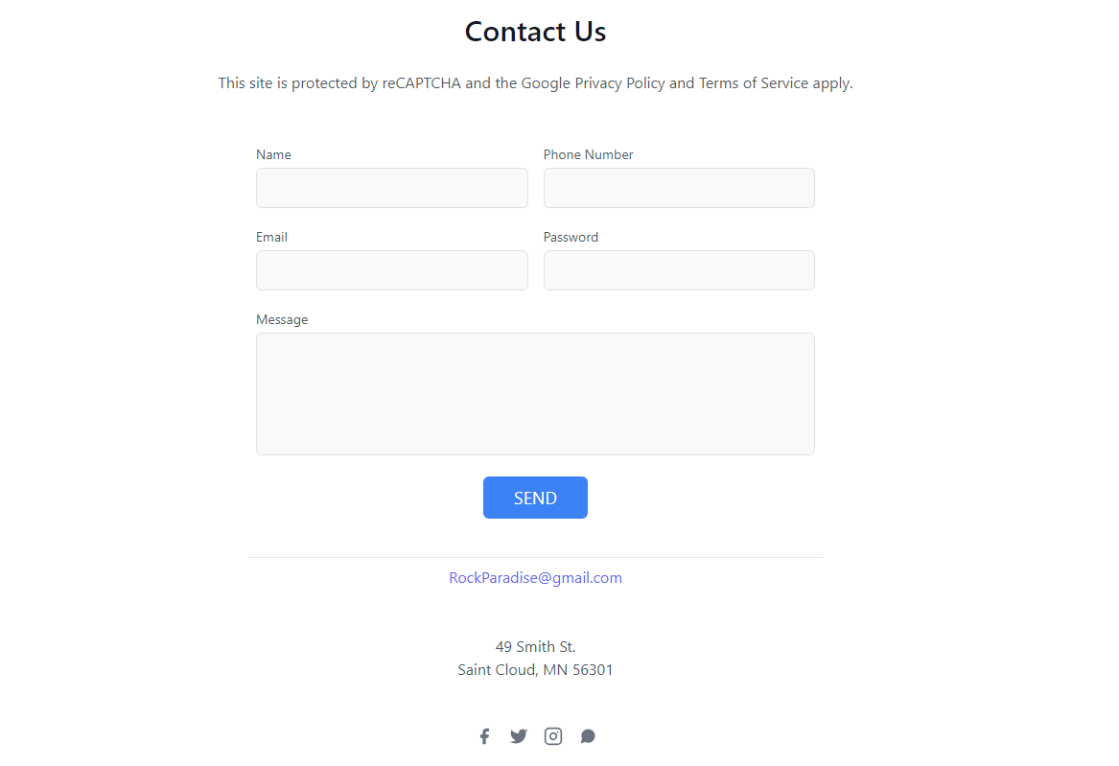

**THANK YOU**

**……….YOUR REGARDS……….**

**“IF YOU HAVE ANY PROBLEMS PLEASE CHECK OUR WEBSITE.”**